Département Informatique et Données Marines

FICHAUT M., BOULANGER D., CARN N.

13/03/2009 – sdn_Mikado_User_Manual_V1.2.0

SeaDataNet

NEMO V1.2.0 : User manual



SeaDataNet

NEMO V1.2.0: User manual

SeaDataNet
Title :

NEMO: user manual

Reference : sdn_Mikado_User_Manual_V1.2.0  Date : 16/03/2009  Version : 1.1.1  Diffusion : open restricted forbidden | number of pages  51  Language :  English

Name | Date | Signature | Diffusion
Name | Date | Signature |  | Nb ex.
Prepared par :
Fichaut M.

Verified by :
Boulanger D.
Carn N.

Résumé :
Manuel utilisateur du logiciel NEMO développé dans le cadre du projet Européen SeaDataNet. Ce logiciel est utilisé pour convertir des fichiers d’un format ASCII quelconque en un fichier au formats ASCII de SeaDataNet : ODV (Ocean Data View) ou MEDATLAS.

Abstract :
User Manual of NEMO software delivered in the frame of SeaDataNet European project. This software is used to reformat ASCII files to one of the ASCII SeaDataNet formats : ODV (Ocean Data View) or MEDATLAS

Mots-clés :
Format, ODV, MEDATLAS

Keywords :
Format, ODV, MEDATLAS

Comments :

History

Version | Date | Status | Comments
1.2.0 | 16/03/2009 |  | Creation

Content

1. Introduction 8
1.1. Main principles 8
1.2. NEMO and MIKADO interactions 8
1.3. Technical characteristics 9
2. NEMO installation and uninstallation 10
2.1. NEMO installation 10
2.2. NEMO uninstallation 11
3. Controlled vocabularies 12
4. Common functionalities 13
4.1. Global description of NEMO’s main screen 13
4.1.1. Left part of NEMO Screen 13
4.1.2. Right part of NEMO screen 13
4.1.3. Bottom banner of NEMO screens 13
4.2. “Set” button 14
4.3. “Test” button 15
4.4. “Validate step” button 16
4.5. “Reset” button 16
4.6. Search function 16
5. NEMO settings 17
5.1. Default language 17
5.2. Default data centre 18
5.3. Default directories 18
5.4. Web services 18
5.5. CDI Author 18
5.6. Default values for CDI 18
5.7. Coupling table 19
5.8. Quality flags mapping 19
5.8.1. Add a new QC flags mapping 20
5.8.2. Remove an existing QC flags mapping 21
5.8.3. Define a default mapping for quality flags 21
5.9. Exit NEMO settings 21
6. Running data file conversion 22
6.1. File description 22
6.1.1. Very important requirement 22
6.1.2. Description of the type of input file(s) 23
6.1.3. Description of the file(s) 24
6.2. Cruise description 25
6.2.1. Ways of fulfilling the information 26
6.2.2. Cruise information 26
6.3. Station description 29
6.3.1. Vertical profiles 30
6.3.2. Time series 35
6.3.3. Trajectories 37
6.4. Data description 38
6.4.1. Menu of the table of measurements 38
6.4.2. How to add a parameter in the table 39
6.4.3. How to keep existing quality flags 42
6.5. File conversion 42
6.5.1. Running file conversion 42
6.5.2. CDI summary file for MIKADO 44
6.5.3. Coupling table for SeaDataNet download manager 45
6.6. NEMO models 46
6.6.1. Save a model 46
6.6.2. Open an existing model 46
6.7. Coupling table management 46
6.7.1. Edit the coupling table 47
6.7.2. Export the coupling table 47
6.7.3. Import a coupling file 48
7. References 49
8. Annexe 1 – Proxy connection to internet 50
8.1. Firefox 50
8.2. Internet explorer 50

Introduction
For purposes of standardisation and international exchange, SeaDataNet has defined common formats [1] for data exchange and distribution which are:
- ASCII SeaDataNet ODV (Ocean Data View) format is a version of the ODV version 4 generic spreadsheet format modified to carry additional information required by SeaDataNet,
- MEDATLAS [2] which is an auto-descriptive ASCII format designed in 1994, by the MEDATLAS and MODB consortia, in the frame of the European MAST II program in conformity with international ICES/IOC GETADE recommendations. As for ODV, the format has been upgraded to carry additional information of SeaDataNet,
- SeaDataNet NetCDF format which is an auto-descriptive binary format still under specifications.

NetCDF and ODV formats are both mandatory in SeaDataNet while MEDATLAS is optional.

NEMO is a reformatting tool able to reformat any ASCII files (input file) of vertical profiles, time-series and trajectories to a SeaDataNet ASCII format (output file at ODV or MEDATLAS format).

Main principles
The input files of NEMO can be individual vertical profiles, time series or trajectories, or files grouping several vertical profiles, time-series or trajectories of the same data type (CTD, bottle cast, currentmeter, thermosalinograph…). All these entities (vertical profile, time-series and trajectory) are called stations in NEMO software.
NEMO is able to reformat :
- a single file or
- a group of files in one directory or
- a group of directories containing several files.
The only requirement is that the input files of NEMO are ASCII, with data measurements in columns.

As the entry file can be all kinds of ASCII format, NEMO must be able to read all these formats to translate them to ODV or MEDATLAS.
To do so, the principle is that the user of NEMO describes the input files formats so that NEMO is able to find the information which is necessary to generate the files at SeaDataNet formats.
One very important pre-requirement is that in a set of input files the information about the stations must be located at the same position: same line in the file, same position on the line or same column if Coma Separated Value (CSV) format. Furthermore, station information must be at the same format in all the stations.
For example: for all the stations, the latitude is on line 3 on the station header, from character 21 to character 27, its format is decimal degrees (+DD.ddd).

NEMO and MIKADO interactions
NEMO was designed to be linked to the SeaDataNet tool ‘MIKADO’ [3] through the generation of a text file that can be converted to Excel.

The principle (Figure 1) is that while NEMO converts one file or a collection of files (like for example a collection of XBT files in a specific geographical area), it also generates a “ CDI summary CSV file” which contains all the minimum information necessary to create CDI records in the SeaDataNet catalogue. This CSV file, once converted to EXCEL, can be read by MIKADO (automatic generation) using a JDBC driver for EXCEL and then XML CDI files are generated (using predefined queries delivered with MIKADO) and can be directly exported to the central SeaDataNet catalogue.


SeaDataNet
CDI
Collection
of
ASCII files
ODV
files
CDI summary
CSV file
MIKADO
XML
CDI files

Figure 1– From « raw » data files to SeaDataNet CDI catalogue

Technical characteristics
NEMO is a portable software that can be downloaded from the SeaDataNet website http://www.seadatanet.org, free of charge, with its user manual.
It is written in Java Language (Version >= 1.6) and it is available under Microsoft (tested with Windows XP and Vista.)
NEMO works offline; however as it uses the SeaDataNet common vocabularies web services to update its lists of values, network connection is needed only when update of these lists is necessary.
- To know if Java is available on your computer, in the right version, follow these steps:
    - Open 'Start' menu, then 'Execute'
    - On the displayed window, enter: 'cmd', then click on 'OK' button
    - Enter 'java -version'
- Check if command has been executed:
    - If not, download the last java version at http://java.com/en/download/index.jsp.
    - Else, check the version displayed. The version should be greater than or equal to 1.6.
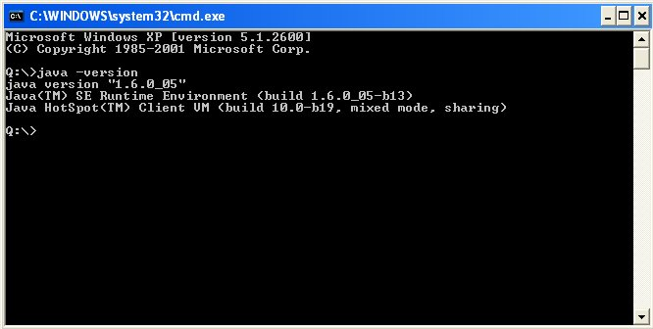
Figure 2 – Check Java version installed on your computer

NEMO installation and uninstallation

NEMO installation
Get NEMO software from SeaDataNet Web site:
http://www.seadatanet.org/standards_software/software/nemo
Copy the zip file on your computer, and unzip it.
You will get 2 files: install_nemo.jar and launcher.bat
If Java is not installed on your computer (see chapter 1.3), install it.
To install NEMO double click on the file launcher.bat.
Then select your language and run the installation :
- Accept the terms of the license agreement.
- Select the installation path (default is C:\ Program Files\NEMO), target directory is created if not exists.
- If you want a shortcut on your Desktop check the box circled in red on the image below. You can create a shortcut for the current user or for all users of the computer (circled in blue), by default “all users” is checked.
Figure 3 – Installation of NEMO – definition of shortcuts.
The shortcuts are created in the desktop and in the Start menu of the computer with the following icon :
on the desktop or in the start menu under the group define in the circled in green field in Figure 3.
Figure 4 – Last screen of NEMO installation
If NEMO needs to be installed on several computers it is possible to “Generate an automatic installation script, by clicking on the appropriate button on the last screen of NEMO installation (Figure 4).

NEMO uninstallation
If you want to remove NEMO from your computer, run the uninstaller by selecting NEMO Uninstaller in the start menu of your computer (see paragraph 2.1).
If running the uninstaller generate the following message :
please run C:\NEMO_Installation_directory\Uninstaller\launcher_uninstaller.bat.
The following window opens :
I
Click on Force the deletion of C:\NEMO_Installation_directory
And then click on Uninstall.

Controlled vocabularies
NEMO includes functionalities to import SeaDataNet controlled vocabularies, EDMO (European Directory of Marine Organisations) catalogue, and some information from IFREMER database useful for MEDATLAS format (such as a subset of Roscop codes corresponding to sensors not yet available on BODC vocabulary or format and default values for MEDATLAS parameters).
SeaDataNet controlled vocabularies used by NEMO are available at the following address: http://seadatanet.maris2.nl/v_bodc_vocab/welcome.aspx

NEMO uses the following list:

List code | List Name
C16 | SeaDataNet Sea Areas
C77 | ICES ROSCOP data types
C174 | SeaDataNet CSR ship metadata
C180 | IOC country codes
L05 | SeaDataNet device categories
L021 | SeaDataNet Geospatial Feature Types
L031 | SeaDataNet Measurement Periodicity Classes
L051 | SeaDataNet sample collector categories
L061 | SeaDataNet Platform Classes
L071 | SeaDataNet data access mechanisms
L081 | SeaDataNet Data Access Restriction Policies
L201 | SeaDataNet measures and qualifier flags
L300 | MEDATLAS Data Centres
P011 | BODC Parameter Usage Vocabulary
P021 | BODC Parameter Discovery Vocabulary
P061 | BODC data storage units
P091 | MEDATLAS Parameter Usage Vocabulary
P091-P011 | Mapping between P091 and P011
P091-P021 | Mapping between P091 and P021 for CDI summary
P091-P061 | Mapping between P091 and P061
EDMO | European Directory of Marine Organizations
Data types | Idem than C77 with sensor information (will be replace by a mapping between C77 and L05)
Parameters | Idem than P091 with default value and format information
Surveys | Use by IFREMER for server initialisation on Cruise step

When running NEMO, the controlled vocabularies can be downloaded when using the menu “Options” and “Vocabulary update”.

Common functionalities

Global description of NEMO’s main screen
NEMO’s main screen is divided into 3 parts that are described in the sections below.
Figure 5 – NEMO main screen

Left part of NEMO Screen
In this left part are the different tabs of NEMO, used to describe the input file(s) (see chapter 6). It is divided into 2 sub-parts, the upper one is used to display the input file, and the lower one is used to input some information about the file.
The input file is displayed on the 4 first tabs on NEMO so that the user can visualize and directly select information in the input file (see chapter 4.2).

Right part of NEMO screen
Right part is used to describe metadata in the input file. It is also on this part that the user can validate or reset each step of the description.

Bottom banner of NEMO screens
All screens of NEMO have the same bottom banner which has 3 tabs named “Errors”, “Info” and “Help”.

Tab “Errors”
This tab gives information about the validation of a step in NEMO or about the data conversion in the last step of NEMO.
If the information is an error, it is written in red, if not it is written in green.

Figure 6 – Example of an error message

Figure 7 - Example of an informative message

Tab “Info”
This tab gives information on the input file or the input directory, and also on the used model, if a model has been loaded.
Figure 8 - Example of content of the Info tab

Tab “Help”
This tab is a “help online” tab which gives information that can be useful for the user. There is one help per main tab of NEMO.
Figure 9 - Help window of the “Description” tab

“Set” button
One principle of NEMO for description of the input file(s) is to select the information in the left part of the screen (where input file is displayed) and then to press the “set” button :
- to input the number of selected lines or
- to input the position on the information (number of the line in the file, and start and end character on the line).
Example :
Number of lines in the station header: The lines of the station header are selected in the left side of the screen (circled in blue), then when pressing the set button, the number of lines is set in the field (circled in red).
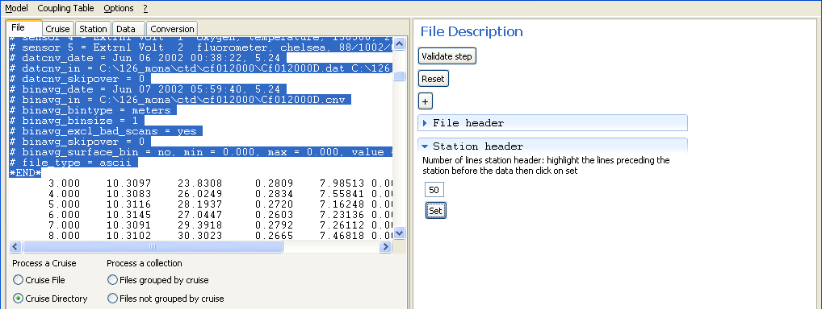
Position of the latitude in the station header: Latitude value is selected in the left side of the screen (circled in blue), then when pressing the set button, the line and the start and end characters are set in the fields (circled in red).
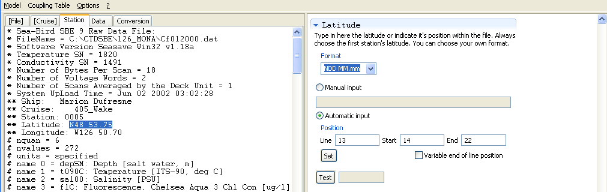

“Test” button
This button is used to verify that the input information is correct. It works for manual and automatic input.
On the example below, the user uses automatic input, he tells NEMO to read latitude on line 13 of each station header from character 14 to character 22 at format NDD MM.mm. Clicking on “Test” displays the value of latitude read by NEMO and translates it at the fixed MEDATLAS format, so that the user is able to check that the value is correct, and that he did not make any input error.
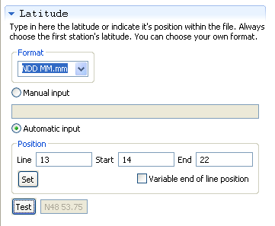

“Validate step” button
The 5 steps of NEMO have to be done sequentially; it is not possible to start with “Cruise” or “Station” tab, for example. It is not possible to go directly from “File” tab to “Data” tab.
To go from one step to another one, NEMO user has to click on the “Validate step” button, on the top right part of NEMO window.
Then NEMO makes some checks: on format, on mandatory fields…
If no error is detected, the current step is validated and it is possible to move to next one. A green informative message is written in the error window: “Step validated, you can proceed to next one”, and brackets appears on the tab name:
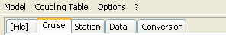
Figure 10 – [File] step is validated, current step is Cruise description not validated yet
If errors are detected, the step is not validated and it is not possible to move to the next one. NEMO user has to read the error message, correct the input and try to validate again.

“Reset” button
The “Reset” button is used to reset the current step: it puts back the values to empty or default value in all the fields of the current window.
If the step was previously validated, by clicking on the “Reset” button its status moves back to “not validated”.

Search function
For some list of values containing a lot of records a search function is available. This function is implemented on all the fields concerning an EDMO code. To open the search function, right click on the field:
This Search function is described into details in chapter 5.6.

NEMO settings
NEMO needs some settings to be able to convert the files, these settings needs to be defined before the first run of NEMO, using the Menu “Options’, “Settings”.
This opens the following window:
Figure 11 – NEMO Settings window

Default language
NEMO is bilingual (English – French) and the default language may be changed here. To be taken into account, once the language has been changed, user has to quit and restart NEMO.

Default data centre
The data centre is the MEDATLAS code (SeaDataNet common vocabularies – List L300) of the data centre which manages the data.

Default directories
Default directories have to be defined for the models and for the data files. These directories will be used by default when opening browse windows for data files and models.

Web services
Web services are used for list of values update, addresses are fulfilled by default when the software is installed and they should not be modified.

NEMO uses 3 different web services:
NEMO Web services to update parameters (format and default values of MEDATLAS parameters), data types and cruise lists
NAUTILUS Web services used by IFREMER for “server initialisation” on the cruise step
SeaDataNet vocabulary Web service used to update all the other vocabulary lists (see chapter 2).

If connection to internet makes use of a PROXY, please see chapter 8.

CDI Author
EDMO ID of the organisation creating the CDI metadata is mandatory, because it is the EDMO code of this organisation and the LOCAL_CDI_ID which determine the iniquity of a CDI records.

Default values for CDI
NEMO is able to create a file which can be used by MIKADO to generate XML CDI files. If a CDI summary file is needed when using NEMO, the user has to click on the “Generate SeaDataNet CDI summary“ check-box and then to input the mandatory CDI information.
This CDI summary file needs information which is defined by defaults in this part of NEMO settings. This CDI information may varies from one dataset to another and it is up to the user of NEMO to update this information each time it is necessary.
These defaults values are, among others, the EDMO codes of the different organisations responsible for the data set(s): Data originator, data distributor or data custodian. At present the list contains around 1500 entries, so to help NEMO user to find a value in the list a search function has been developed.
To open the search function, right click on the list, a search menu opens:
Click on Search opens the search window:
Then the user can type the character string he is looking up, to filter the list of organisations (in the following example, looking up ‘sism’):
Two fields concern the data distribution:
Data distribution Website: the default value http://www.sdn-taskmanager.org/ should not be changed; it is the address of the central CDI web interface, where SeaDataNet users will have to connect to search data.
Data distribution method: gives the access mechanism of the data set. The list of values comes from SeaDataNet common vocabularies (List L071) gives the access mechanism for the data set.
Platform class: this mandatory field for CDI described the type of platform which has collected the dataset. The list of values comes from SeaDataNet common vocabularies (List L061).
Data set access: this mandatory field for CDI described the data access restriction policies of the dataset. The list of values comes from SeaDataNet common vocabularies (List L081).

Coupling table
If the “Generate mapping for SeaDataNet download manager” check-box is clicked, NEMO will insert all the converted stations LOCAL_CDI_IDs in a java database included into NEMO software. This coupling table gives the mapping between the unique identifier of a CDI element (LOCAL_CDI_ID which corresponds to a vertical profile, a time series or a trajectory) and the file in which this element can be found. It is managed by the “Coupling table” menu of NEMO (see paragraph 6.7).

Quality flags mapping
NEMO is able to convert input file with quality flags to SeaDataNet quality flags scale.
Different quality flags mapping can be used and safeguarded within NEMO software.
The flag window is divided into 2 parts, on the left is the list of existing mappings, on the right are the details of each mapping to SeaDataNet quality flag scale.

Figure 12 - Mapping quality flag scale.
On the left : list of existing mappings, on the right : detail of the selected mapping

Add a new QC flags mapping
To add a new mapping:

- right click on the list of mapping to open the menu:

- click on “Add” to add a new line in the list of mappings :
- change the label of the new mapping :

- Then in the right part of the window, enter the flag mapping (same principle than previously, right click opens a window which allows adding or removing a line from the mapping table). Once a new line is created, the value of the local flag, and the mapping between this local flag and SeaDataNet QC flag need to be input as following :

Remove an existing QC flags mapping
To remove an existing mapping :
- select the line corresponding to the mapping that needs to be deleted
- right click on the list of mappings to open the menu :

- click on “Remove”

Define a default mapping for quality flags
To define a mapping « by default », right click on the mapping in the mapping list and select Default in the Menu. The default mapping is written in bold characters in the mapping list.
In the station step, the default mapping flags will be proposed if no mapping has been defined yet.

Exit NEMO settings
There are 2 ways of exiting NEMO settings window :
- click on Validate to save changes and to exit settings window, or
- click on Cancel to exit without saving the changes.

Note that you need to quit and re-start NEMO to take into account new quality flags mappings at Station step.

Running data file conversion

To convert input file(s), NEMO user has to proceed 5 steps, which correspond to 5 tabs in NEMO interface (Figure 13):
- Describe the type of file and the type of measurements
- Describe the cruise (only if the files are related to one cruise)
- Describe the station information
- Describe the measured parameters
- Convert the input file(s)
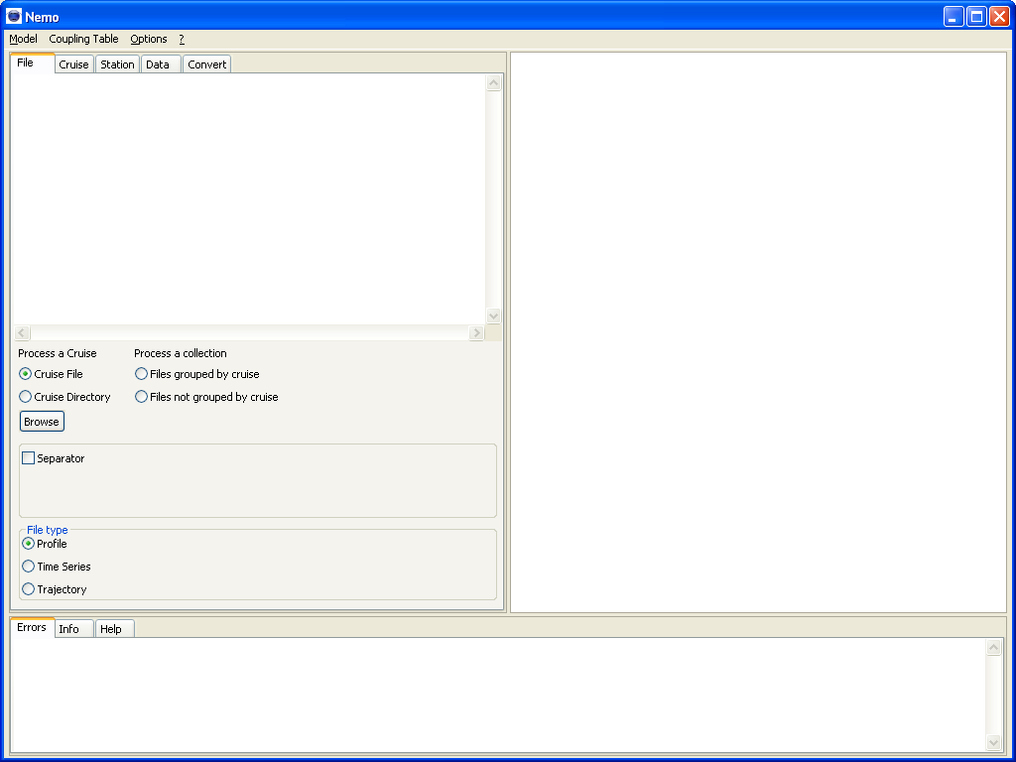
Figure 13 - Main screen of NEMO with the 5 tabs corresponding to the 5 steps of conversion
During this chapter we will describe each of these steps.

File description

Very important requirement
NEMO can translate almost any kind of ASCII format, but in one execution, NEMO will convert only similar files: the files are homogeneous (same data type: CTD or Bottle but not both), the information must be located at the same place in all the files that NEMO will reformat in one execution.
Examples :
- User wants to reformat CTD, bottle and current meters of one cruise, he will have to run NEMO three times: one for CTDs, one for bottles and another one for current meters.
- User wants to reformat a set of XBTs collected during several cruises :
  - He can do it in one execution if the XBTs have the same input format.
  - He must run NEMO three times if he has 3 different input format of XBTs (SIPPICAN, DEVIL and SPARTON)

Description of the type of input file(s)
The “File” step consists first in a high level description of the file(s) that needs to be converted: this description is included in the left side of the “File” window.
First step is to describe the type of dataset that is going to be converted (=input files):
- Are the data related to one cruise?
  - If yes, is it one file for one cruise (one file for all stations)?
  - Or, is it a set of files in one directory (one file for each station)?
In the case of data related to one cruise, data conversion to MEDATLAS or ODV will be both allowed.
- Are the data related to several cruises?
  - If yes, are they grouped by cruises (one directory per cruise)?
  - Or not (one directory with all the files of all cruises)?
In case of data conversion related to a collection of cruises or a collection of stations, cruise metadata which are mandatory in MEDATLAS are not available, so data conversion in MEDATLAS is not allowed; only conversion to ODV will be available in “Conversion” tab.
Once previous information is given, the user gives the path to input file(s) to NEMO, using the “Browse” button, and the first file of the first input directory (in case of multiple files) or the specified file (in case of one unique input file) is opened in NEMO window (Figure 14). :
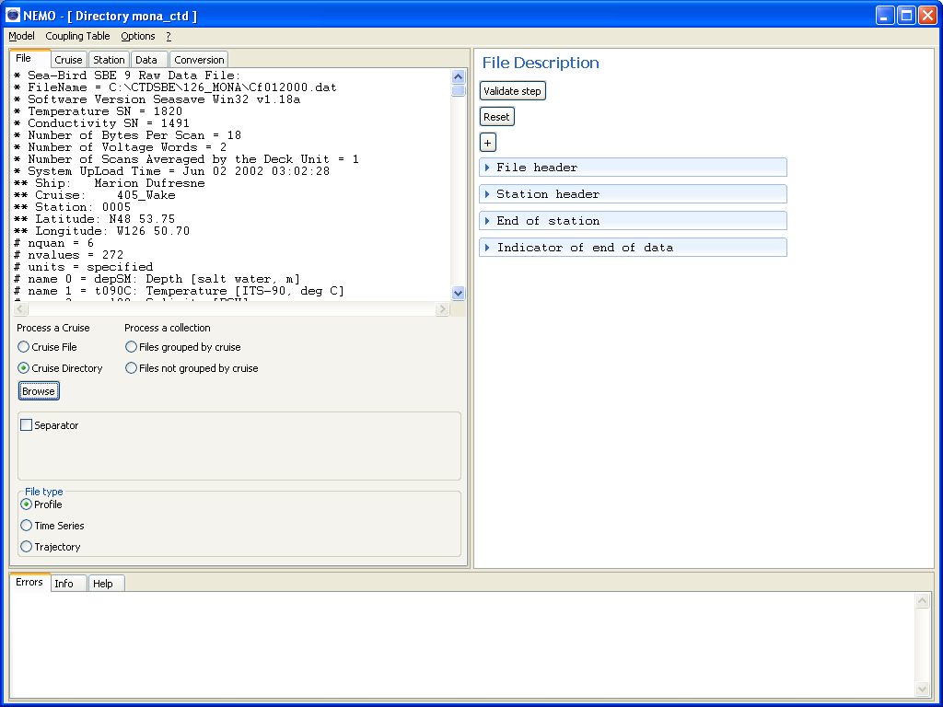
Figure 14 – File description screen of NEMO – Left part (in red) for the description of the type of input file(s)
Then the user must tell NEMO if the file(s) contains separators (and which one) or not.
Finally, NEMO needs to know if the files are related to vertical profiles, time series or trajectories.

Description of the file(s)
Once the type of file have been described, the user must describe the file itself, this second part of the “File” step is included in the right side of the “File” window:
Figure 15 – File description screen of NEMO – Right part (in red) for the description of input file(s)
4 fields need to be fulfilled:
- File header
This field describes the number of lines of the file header. A file header is generally present when it is a multi-station file, and that there are some lines at the beginning of the file which are related to all the stations. These lines are not repeated in the file.
The number of lines of the file header can be input manually or selected in the left part of the screen in the file and then input through the “Set” button (cf paragraph 4.2).
Remark : This number of lines can be different from zero only if you selected "Cruise File” in the description of the type of input file(s).
- Station header
This field describes the number of lines of the station header. A station header is a set of lines containing information on the station. Theses lines are the lines before the data lines; they are repeated for each station.
The number of lines of the station header can be input manually or selected in the left part of the screen in the file and then input through the “Set” button (cf paragraph 4.2).

- End of station
This field describes the number of lines of the end of a station. These lines are generally present when it is a multi-station file and there are several lines between each station. The indicator of end of data (see below) must not be taken into account in this number of lines, so if it is the only line between 2 stations, the number of line for the end of station must be set to zero.
The number of lines of the end of station can be input manually or selected in the left part of the screen in the file and then input through the “Set” button (cf paragraph 4.2).
- Indicator of end of data
This field describes the data rupture indication.
For single station file, most of the time the end of file (EOF) is the indicator of end of data, but it may be an empty line at the end of the file or a line with a specific text (like in MEDATLAS file for example where the last line of a station is a line of default values, that must not be taken into account as measurements) that can be input manually or selected in the left part of the screen in the file and then input through the “Set” button (cf paragraph 4.2).
For multiple stations file, NEMO needs a separator between the stations to be able to know that station is changing. This separator which can be an empty line or a set of specific characters that can be input manually or selected in the left part of the screen in the file and then input through the “Set” button (cf paragraph 4.2).
For example, in a MEDATLAS file, the indicator of end of data is the line starting with “-999.9 99.999”. It is not necessary to type all the line; the first significant characters are enough.
When the file description is over, click on “Validate step” (cf. paragraph 4.4) to move to next step.
Remark: In the case of data file with separators, NEMO will rewrite the files without separators before moving to the next step. During this stage of rewriting the files, an informative message is written in the errors window (with progression bars on Data analysis and writing files). The files are rewritten in a directory called PF_[name of the input directory].

Cruise description
This step is performed only in case of processing one cruise: that means that in “File” tab, “Cruise file” or “Cruise directory” has been selected. The cruise metadata is mandatory for conversion to MEDATLAS format.
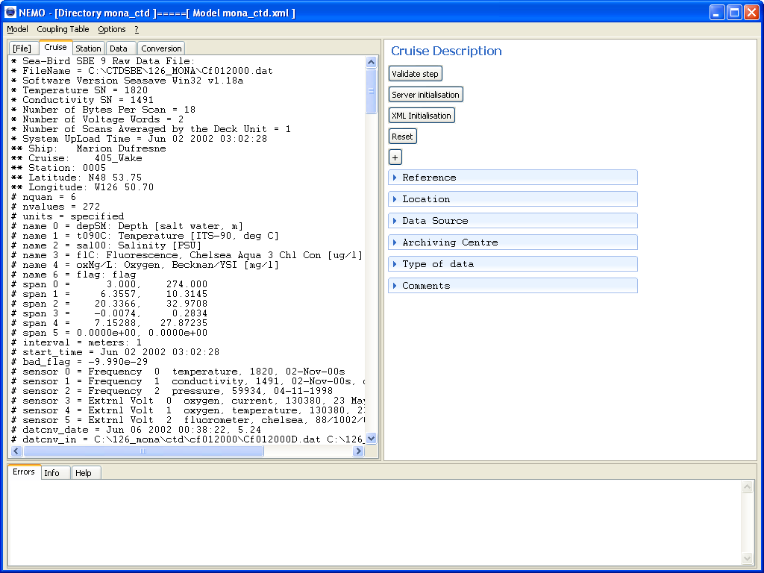
Figure 16 - Cruise description screen of NEMO

Ways of fulfilling the information
There are 3 ways of fulfilling the cruise information in NEMO:
- Server initialisation
This is specific for IFREMER/SISMER use; it uploads the cruise information from SISMER database using the NAUTILUS Web service.
- XML initialisation
This is to import the information from SeaDataNet XML file (generated by MIKADO or other tools). The actual version of NEMO is compatible with the version 1.3 of CSR XML schema.
- Manual input
If no automatic import of CSR information is available, NEMO user can manually input the information.

Cruise information
Several sections must be filled; they are described in this chapter.

Reference
This section describes the reference of the cruise; the 3 fields are mandatory:
Cruise reference: in the example given, it is a MEDATLAS reference which is composed as described in the MEDATLAS format description [2].
Ship: the list of ship is the C174 ship list of SeaDataNet common vocabularies.

Location
This section describes the temporal and geographical location of the cruise; the 3 fields are mandatory:
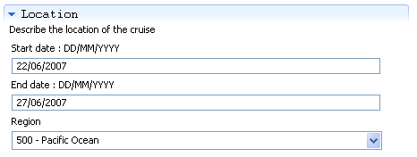
Region: the list of regions is the C16 sea areas list of SeaDataNet common vocabularies.

Data source
This section describes the source country, laboratory, project and chief scientist of the cruise. The country and the chief scientist are mandatory.
Country: the list of countries is the C180 IOC country codes list of SeaDataNet common vocabularies.
Laboratory, Chief scientists and Project are free text fields.

Archiving centre
This section describes the data centre where data are archived and the MEDATLAS code for the data availability.
Data centre: the list of data centres is the L300 MEDATLAS data centres of SeaDataNet common vocabularies. By default the data centre is the one given in NEMO settings (cf. paragraph 5.2).
Confidentiality: it corresponds to the MEDATLAS code for data availability that can take one of the following values: P – Public, L – Limited, C – Confidential.

Type of data
This section deals with the ROSCOP code of data found in the files that are going to be converted.
Data type code is the ROSCOP code; it is the C77 ICES ROSCOP data types list of SeaDataNet common vocabularies.
At least one data type with Sensor at true is mandatory.
“Number” represents the number of stations with the corresponding data type in the file; it can not be equal to 0. In this example, the cruise file contains 8 CTD stations, each of them has dissolved oxygen measurements.
A right click on the list opens the following window:
To add a code in the list, click on “List selection” and you will get a window to choose a new data type:
When the data type is selected in the list, click on “Select” to add it in the list of data types of the cruise, and then change the number of stations which is set to 0, by default.
To delete one or several data types: select the line(s) to be deleted by left click on the left hedge of the data type lines (use Shift and/or Control to select several lines), then right click on the list and select “Delete current type” in the menu.
It is also possible to move up or down a current data type in the list.

Comments
This section is used to input comments about the cruise or the data measurements. There is no limitation on the number of comment lines.
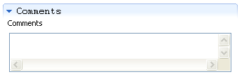

When the cruise description is over, click on “Validate step” (cf. paragraph 4.4) to move to next step.

Station description
This step is performed to indicate to NEMO where to find the mandatory or important information in the station header(s) of the file(s). This information is changing as it deals with vertical profiles, time series or trajectories.

Vertical profiles
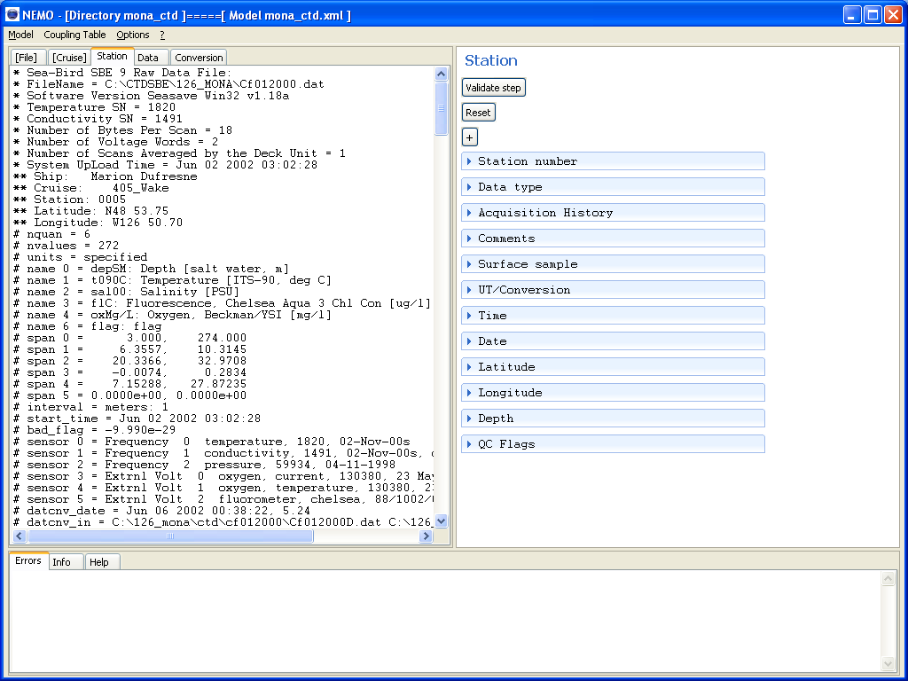
Figure 17 - Station description window for vertical profiles
Mandatory fields are: Station number, Data type, Time, Date, Latitude and Longitude.

Fields Acquisition History, Comments, Surface Sample and UT/Conversion can’t be described on a data line.

Station number:
The station number can be incremental starting at a number given by the user or can be in the station header and input in NEMO using the set and test buttons (paragraphs 4.2, 4.3).
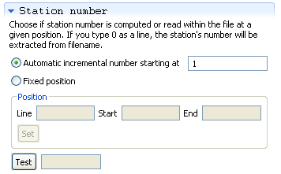

Remark: If station's number is located within the filename, use 0 as line number, and give the start and end character in the file name.

Data type:
It is the ROSCOP code of the instrument (H10 - Ctd for example) used for data collection; it is selected in the list of data types input during the previous step (cruise description).
If processing a collection of files, “Data type” field is not available, it will be asked during conversion step.

Acquisition history:
They are 2 lines for comments about method and/or instrument used for data collection. They can be manually or automatically input, in the following fields.

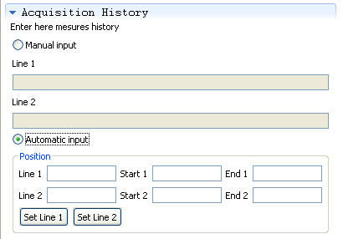

Comments:
Comments about the station can be manually or automatically input. There is no limitation on the number of comment lines.
If the comment is spread among several lines which do not have the same length, click on “Variable end of line position”.

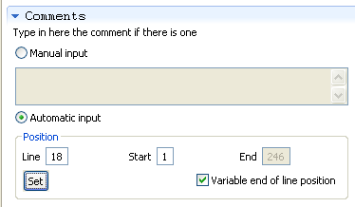

Surface samples:
Same principle as Acquisition history, 2 lines for comments about surface samples if there are some.

UT/Conversion:
This field is to manage non universal time in the input files.
If station time in the input file is TU-5, type 5 (or read by automatic input) in the UT/Conversion field and NEMO will add 5 hours to the input time. If time in the input file is TU+5, type -5 in the field.
The default value is zero, for this field.

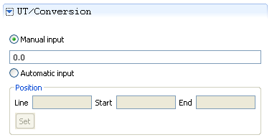

Time:
This field concerns the time of stations.
User needs to input the format in which time is provided in the input file and then, he has to set and test the value (paragraphs 4.2, 4.3).
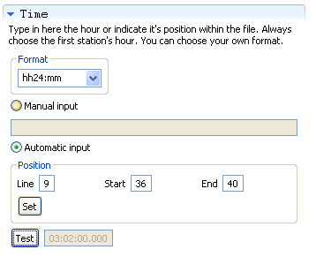
To describe the format, user must either select a predefined value in the list, or he can create its own format within the following:
hh: hour expressed in 2 digits (hh24 indicates time on 24 hours)
mm: minutes expressed in 2 digits
cc: hundredth in the time expressed in 2 digits
ss: seconds expressed in 2 digits
ttttt: seconds expressed in 1 up to 5 digits
PM: allows NEMO to read PM and AM time

Example of valid formats for time:
22:30:15 ➔ hh24:mm:ss
10-12 AM ➔ hh-mm PM
17.15 ➔ hh24.cc (converted to 17:25:00.000)

Remark: In the test field, time is displayed at ISO format, if UT/conversion field contains a value different from 0, the displayed time takes into account the time conversion to UT.

Date:
This field concerns the date of stations.
User needs to input the format in which date is provided in the input file and then, he has to set and test the value (paragraphs 4.2, 4.3).

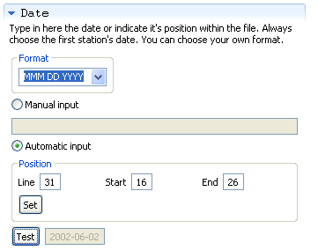
To describe the format, user must either select a predefined value in the list, or he can create its own format within the following:
YY or YYYY: year expressed in 2 or 4 digits
MM: month expressed in 2 digits
MMM: month expressed in 3 alphabetic characters
DD: day in the month expressed in 2 digits

Note that the format for date is case sensitive; mm means minutes and not month (MM).

Example of valid formats for date:
2008/07/10 ➔ YYYY/MM/DD
86-07-10 ➔ YY-MM-DD
Jun 10 2002 ➔ MMM DD YYYY

In the test field, date is displayed at ISO format.

Latitude and Longitude:
These fields concern the latitude and longitude of stations.
User needs to input the format in which latitude and longitude are provided in the input file and then, he has to set and test the values (paragraphs 4.2, 4.3).

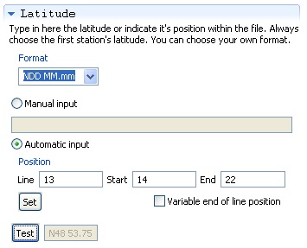
To describe the format, user must either select a predefined value in the list, or he can create its own format within the following:
N: expresses the hemisphere. Input values have to equal N or S in the case of latitudes and W or E in the case of longitudes
+: expresses the hemisphere. Input values have to equal ‘ ’ or ‘+’ to express N in the case of latitudes, E in the case of longitudes and ‘-’ to express S in the case of latitudes, W in the case of longitudes
DDD or DD or D: Degrees
DDD.ddd or DD.ddd: Degrees in decimal values. The maximum number of D must be 3 in the case of longitudes and 2 in the case of latitudes
DDD.ddd or DD.ddd: Degrees in decimal values. The maximum number of D must be 3 in the case of longitudes and 2 in the case of latitudes. The number of 'd' characters expresses the number of decimals.
MM: Minutes
MM.mm: Minutes in decimal values. The number of 'm' characters expresses the number of decimals.
SS: Seconds

Example of valid formats for latitude and longitude:
W123 10.25 ➔ NDDD MM.mm
7.12345 ➔ +D.ddddd
-123. 175 ➔ +DDD.ddd
S45 10’ 55’’ ➔ NDD MM SS

In the test field, latitude and longitude are displayed at MEDATLAS format.

Click on “variable end of line position” if all latitudes and longitudes do not end at the same character in every station (this often happens with not significant zero values)
For example:
Latitude: +25.205
Latitude: +25
Latitude: +25.15
These 3 lines (in 3 different stations of the same dataset) will be described as +DD.ddd with “variable end of line position”.

Depth:
This field concerns the bottom depth of stations, which must be given in meter in the input file. This field can be input manually or automatically.

QC Flags:
This part concerns the quality flags on station header information that could exists in the input file.
Header QC flags are only used in MEDATLAS format, they concerns Date/Time, Latitude, Longitude and Bottom depth.

If some quality flags exist in the input file, it is necessary to have their mapping with SeaDataNet flag scale. To do so, it is possible to add and remove values in the mapping list or to load an existing mapping (paragraph 5.8). To open the menu, Right click on the mapping table.

Remark: if the input file has the same quality flag scale than SeaDataNet, no mapping is necessary.

Then, when mapping is done, the location of the 4 quality flags can be input.
Right click on the table to open the menu:

Then you can add or remove a line. On the example, here, user is adding a line for longitude flag.
Once one line is added, the flag has to be selected in the file (left part of NEMO window) and set in the table by clicking on Set start/end in the menu. The value can be tested by clicking on “Test” in the menu.
When the station description is over, click on “Validate step” (cf. paragraph 4.4) to move to next step.

Time series
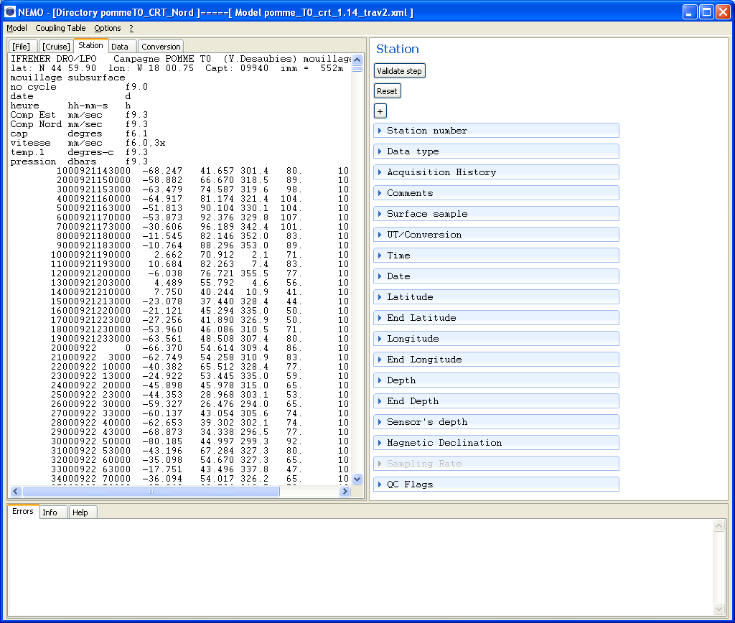
Figure 18 - Station description window for time series
Mandatory fields are: Station number, Data type, Time, Date, Latitude, Longitude and Sensor’s depth.

Fields Acquisition History, Comments, Surface Sample, UT/Conversion, End Latitude, End Longitude, End Depth and Sampling Rate can’t be described on a data line.

In this paragraph we will only describes specific fields to time series, for others the description is the same than for vertical profiles.

Time and date :
If time or date are selected in the first line of measurements in the file displayed in NEMO window, date and time must be input automatically and Sampling Rate field is disabled.

End Latitude and End Longitude:
These fields concern the latitude and longitude of the end time of time series.
By default, if not input, the values will be the same than “Latitude” and “Longitude” which are considered as the position at the start time of the time series.
Input in these fields is the same than for “Latitude” and “Longitude” described for vertical profiles.

End Depth:
This field concerns the bottom depth at the end time of time series.
By default, if not input, the value will be the same than Depth which is considered as the bottom depth at the start time of the time series.
Input in this field is the same than for “Depth” described for vertical profiles.

Sensor’s depth:
This field concerns the depth of the sensor measuring time series. It must be given in meter in the input file. This field can be input manually or automatically.

Magnetic Declination:
This field concerns the magnetic declination at the location of the time series, useful for current meters. The declination is a signed integer: W007 declination must be input as -7 and E005 as +5 or 5. This field can be input manually or automatically.

Sampling Rate:
This field concerns the sampling rate of the sensors. This sampling rate can be input manually, or automatically. NEMO will calculate it automatically if time and date are selected in the first line of measurements.

The unit of the sampling rate is Second. If it is not given in second in the input file, it must be converted by using the field “Conversion formula” (example : if the sampling rate is given in Hour in the input file, input *3600 in the formula).

Qc Flags:
It is the same principle that for vertical profiles except that in the case of time series there are more QC flags, in the station header in MEDATLAS format.
A right click on the table of Metadata flags will open the menu, the following flags are available:
Date/time, End Data/Time, Latitude, End latitude, Longitude, End longitude, Depth, End depth, Sensor Depth.
When the station description is over, click on “Validate step” (cf. paragraph 4.4) to move to next step.

Trajectories
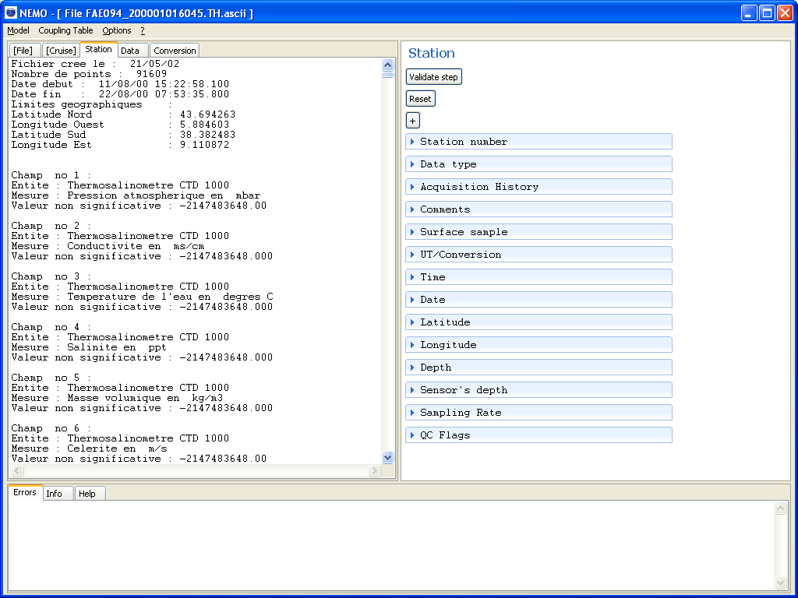
Figure 19 - Station description window for trajectory
Mandatory fields are: Station number, Data type, Time, Date, Latitude and Longitude, Sensor’s Depth.
Fields Acquisition History, Comments, Surface Sample, UT/Conversion, and Sampling Rate can’t be described on a data line.
Fields Latitude, Longitude, Depth (if exiting) must be described on a data line. End Latitude, End Longitude and End Depth (if existing) are the last data line value of Latitude, Longitude and Depth. These information are also automatically informed by NEMO.
In this paragraph we will only describes specific fields to trajectories, for others the description is the same than for vertical profiles or time series.
Station number :
In ODV, a trajectory is considered as a series of stations with one point of measurement at each station, but the LOCAL_CDI_ID is the same for all the stations. In MEDATLAS a trajectory is only one station within which latitude and longitude are considered as measured parameters. The station number cannot be incremental.
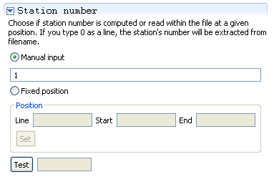
When the station description is over, click on “Validate step” (cf. paragraph 4.4) to move to next step.

Data description
This step is performed to indicate NEMO where to find the data measurements in input file(s). This information concern the name and unit of the measured parameters, their default values (found in the input file when the parameter is not measured), and the format in which the parameter will be kept in the output file.

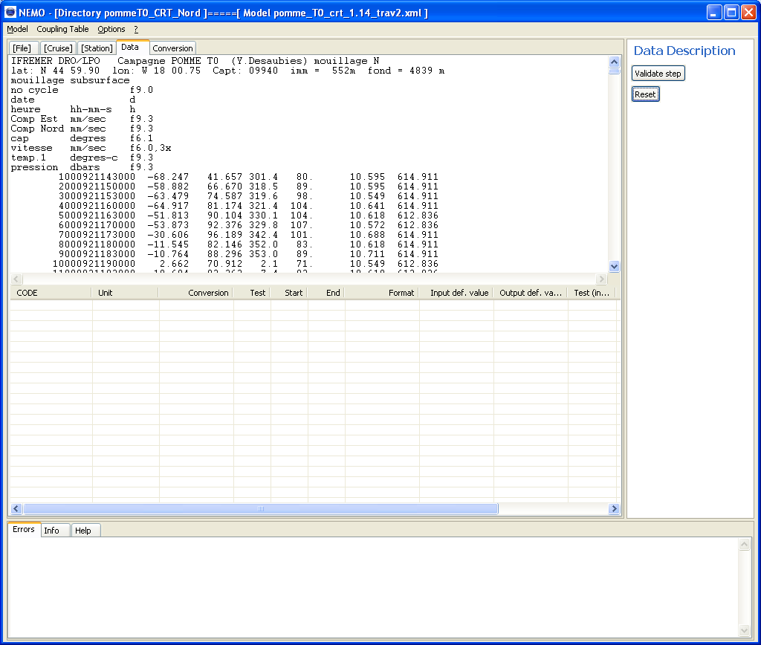
Figure 20- Data description window
If input files concern vertical profiles, PRES (for sea pressure in decibars) is a mandatory parameter; it is input by default when entering the step, and it cannot be deleted (it is a MEDATLAS requirement).

If input files concern time series, date and time of measurements will be automatically put in output files, they do not need to be described in the measurement description.

If input files concern trajectories: date, time, latitude, longitude and bottom depth (if existing) of measurements will be automatically put in output files, they do not need to be described in the measurement description. If DEPH is a measured parameter, it must be the first in the list of parameters.

Menu of the table of measurements
Right click on the table of measurement opens the following menu:
Figure 21 - Menu of measurements table
The role of each item of the menu is explained here after:

Set start/end:
Used to set the start and end character of the selected parameter in the data line. The value of the parameter has to be highlighted on the first data line before using this menu.

Update test:
Used to insert the value in the test fields including : “Test” (for the measured parameters), “Test (input)” for the value of the quality flag read in the input file and “Test (output)” for the value of the quality flag in the output file.

Parameter list:
Used to add a new parameter in the table of measured parameters.

Move current type up:
Used to move up a parameter in the table of measured parameters. The order of parameters in the table defines the order of parameters in the output file.

Move current type down:
Used to move down a parameter in the table of measured parameters. The order of parameters in the table defines the order of parameters in the output file.

Delete current type:
Used to delete a parameter from the table of measured parameters.

Set flag:
Used to set the start and end character of the quality flag the selected parameter. The value of the flag has to be highlighted on the first data line before using this menu.

Delete flag:
To delete the quality flag information of the selected parameter.

How to add a parameter in the table
To add a parameter in the table, click on Parameter list, it opens the “Parameters selection” window:

Select the parameter in the list (use the filter to find a specific parameter), in the example below, there is a filter on “current”.

The selected parameter is added in the table, with some values filled by default; all these default values can be modified. The default and the format values linked to the parameter are downloaded in the parameters list of NEMO Web service.

Conversion:
This field is used to input a conversion formula which should be like x*1000+3; with x the value read in the input file(s).

Example:
In the example below (Error: Reference source not found), the East component of the current is given in millimetre/second as in the output file it is in meter/second, so a 0.001 factor has to be applied on the value read in the input file.

Figure 22 - Example of an input value converted through a formula

Test:
This field displays the value as it will be written in the output file.
To input value in the test field, right click in the table and choose “Update test” in the menu of Error: Reference source not found; the start and end fields must have been input before.
In theFigure 22Figure 22 example, the test value takes into account the conversion formula and the output format (column format) which says 3 decimal digits.

Start-End:
These fields indicate the start character and the end character of the parameter in the data line.
To input the values in these fields, you have to select the measured parameter value on the first line of measurement, then right click in the table and choose “Set start/end” in the menu of Figure 21.
In the Figure 22 example, East component of the current starts at character 23 and ends at character 30 in the data line.
Remark: don’t forget to take the maximum length of the value into account; it may not be the same length than the one on the first line of data.

Format:
This field describes the output format (in the output file) of the measured parameter.
The user has to describe the output format within the following:
%xd: x = number of digit,
d for integer
%3d ➔ 150
%5d ➔ 15000
%+xd: same than %xd but for signed values
%+4d ➔ +150 or -150
%+6d ➔ +15000 or -15000

%x.yf = x= total number of digits, included the decimal point
y= number of digits to the right of the decimal point
f for decimal number
%6.3f ➔ 12.124
%5.1f ➔ 123.4
%7.5f ➔ 1.12345
%+x.yf : same than %x.yf but for signed values
%+6.3f ➔ +12.124 or -12.123
%+5.1f ➔ +123.1or -123.1
%+7.5f ➔ +1.12345 or -1.12345

Input def.value:
This field describes the values found in the input file where the parameter is not measured.
This input value can be any type of characters (number, alphabetic).

Output def. value:
This field describes the values written in the output file where the parameter is not measured.
The output value must be a number (often a suite of ‘9’) at the same format than the measured parameters described in the format column.

How to keep existing quality flags
In the table of measured parameters, information on quality flags that may exist in input file(s), can be input in the 4 last columns of the table of measured parameters (Test (input), Test (output), Start flag, End flag).
To input the start and end positions of quality information:
- Highlight the quality information in the first data line of the input file in NEMO window
- Click on “Set flag” in the menu of Error: Reference source not found
In the example below, the first parameter of the table has a quality flag on character 28 of the data line, the second parameter has a quality flag on character 29 of the data line, the third parameter has a quality flag on character 30 of the data line and the fourth parameter has a quality flag on character 31 of the data line. For all of them the input value of the QC flag is the same than the output value (here 0).
To delete flag information from the table of measurements:
- Highlight parameter line where you want to delete this information
- Click on “Delete flag” in the menu of Error: Reference source not found
Current flag scale conversion is the one loaded in the previous step (Paragraph 6.3.1, Qc flags).
When the data description is over, click on “Validate step” (cf. paragraph 4.4) to move to next step.

File conversion
This is the last step of NEMO; once the description of the input file(s) is completed, it is possible to run the conversion either to ODV or to MEDATLAS format.
This conversion step generates:
- output file(s) at the needed format
- If “Generate SeaDataNet CDI summary” is clicked in NEMO settings, a CDI summary file will be created while NEMO is converting the input file(s). It is a Coma Separated Values (CSV) file that can be converted to an Excel file directly usable by Mikado to generate a CDI XML export, corresponding to the stations that are converted to ODV or MEDATLAS format.
- If “Generate mapping for SeaDataNet download manager” is clicked in NEMO settings, mapping information (for all the stations that are converted to ODV or MEDATLAS format) are inserted in the local database of NEMO.
If both conversion to MEDATLAS and ODV are available, user can generate both formats consecutively without revalidating all the steps.

Running file conversion
The user needs to proceed as follow:
- choose between MEDATLAS or ODV format by checking the appropriate box
- check “Sort data within stations by increasing reference parameter (Pressure or time)” button if he wants to be sure that the measured parameters are sorted by the reference parameter in the output file. Be careful that doing so you can mix up and down casts CTD data for example.
- Then click on start conversion, the user is asked:
  - to enter a reference for the dataset if he is converting to ODV format, by default le cruise reference is proposed to the user if he is converting data related to one cruise, otherwise a free text to identify the dataset can be input.
  - to enter a name for the CDI-summary file if “Generate SeaDataNet CDI summary” is clicked in NEMO settings
  - to enter the data type if he is converting a collection of files
  - to enter a name for the output directory or the output file
  - to enter a name for the output directory prefix if “Generate mapping for SeaDataNet download manager” is clicked in NEMO settings. This prefix will be subtracted from the file name in the mapping table.
For example if
output file name = C:\username\NEMO\cruise_name\file_name
and output directory prefix = C:\username\NEMO
file name in the mapping table will be : cruise_name\file_name

Then the conversion starts and user is informed about its progression in the “Errors” tab at the bottom of the window.
When the conversion stops:
- there may be an error, detailed in the “Errors” tab in red, or
- conversion is completed and a green message informs the user.
Figure 23 -- File conversion window, with an ODV conversion completed

CDI summary file for MIKADO

Description
If “Generate SeaDataNet CDI summary” is selected in NEMO settings, NEMO generates a CDI summary CSV (Comma separated value) file which has to be converted to an Excel file to be used by MIKADO [3].
This CSV file contains all the necessary information for the generation of a SeaDataNet XML CDI file. The content of the CSV summary file for CDI is described in the following table:

Name | Content | Comment
LOCAL_CDI_ID | CDI ID in the data centre generating the CDI | [Cruise reference]_[Station number]_[Data_type]  Example : FI352002200040_00005_H10  Or  [data set reference]_[Station number]_[Data type]  Example: XBT_2002_00005_H13 :
EDMO AUTHOR | EDMO ID of the data centre responsible of the CDI | Input in NEMO settings
AREA_TYPE | Type of measurement | SeaDataNet Geospatial Feature Types (SeaDataNet common vocabulary , List L021)  Set to ‘Point’ If vertical profiles and time series and to ‘Curve’ if trajectories
DATASET_NAME | Name of the dataset | Set to ‘Not Specified’, if cruise, set to Cruise Name, if dataset reference exists set to dataset reference
DATASET_ID | Dataset_ID | Set to ‘Not Specified’, if cruise set to Cruise reference, if if dataset reference exists set to dataset reference
DATASET_REV_DATE | Date of last revision of the dataset | Date of the day at ISO format YYYY :MM :DDTHH24 :MI :SS
EDMO_ORIGINATOR | EDMO_ID of the dataset originator | Input in NEMO settings
DATASET_ABS | Abstract describing the dataset | Set to ‘Not specified’
EDMO_CUSTODIAN | EDMO code of the organisation managing the dataset | Input in NEMO settings
PDV_CODE | Measured parameters | BODC Parameter Discovery Vocabulary (SeaDataNet common vocabulary, List P021).  The mapping between MEDATLAS codes input with NEMO and P021, is done automatically.
PLATFORM_TYPE | Platform class | SeaDataNet Platform Classes (SeaDataNet common vocabulary, List L061).  To be input by the user.
DATASET_ACCESS | Dataset access restrictions | SeaDataNet Data Access Restriction Policies (SeaDataNet common vocabulary, list L081).  To be input by the user.
CRUISE_NAME | Cruise name | If cruise : set to cruise name  If collection of files grouped by cruise set to the name of the directory  If collection of files not grouped by cruise = set to ‘Not specified’
STATION_NAME | Station name | Set to station number
STATION_LATITUDE | Latitude of the station | If trajectories and time series: start latitude
STATION_LONGITUDE | Longitude of the station | If trajectories and time series : start longitude
STATION_DATE | Date of the station | If trajectories and time series : start date and start time
EDMO_DISTRIBUTOR | EDMO code of the organisation distributing the dataset | Input in NEMO settings
Name | Content | Comment
DATA_SIZE | Size of the data file | For profiles and time-series :  If one file per station = Size of the file in Mbytes  If one file per cruise : Size of the Cruise file/number of stations in Mbytes  for trajectories : size of the file in Mbytes
DIST_WEBSITE | Distribution website | Must be set to « http://www.sdn-taskmanager.org/ »  Input in NEMO settings
DIST_METHODE | Distribution method | SeaDataNet data access mechanisms (SeaDataNet common vocabulary, List L071).  Input in NEMO settings
This text file has to be open with Excel and converted to Excel file to be usable by Mikado.

Use of the CDI_summary file with MIKADO
- Open the CDI summary text file with Excel and verify that is contains the right information for your dataset.
- This file has one Excel sheet that you have to rename STATION.
- Save the file as an Excel file (*.xls).
- Close the Excel file.
- Run Mikado (see chapter 9.2.3 of MIKADO user manual) [3]
- Select the following menus : Automatic, Open, CDI
- Choose the file : [NEMO_installation_directory]\ summary_CDI_NEMO.xml
- In the Connection tab, click on Excel Preset button and select the Excel file of step c).
- Save your new configuration with Save as (to preserve the original configuration delivered with NEMO software).
- Select the following menus : Automatic, Generate, CDI and open the configuration file created at step i).
- Choose the export directory for your XML CDI files.
- Export the files.
- Test the generated XML files with SeaDataNet validator at the following address: http://www.seadatanet.org/validator.

Coupling table for SeaDataNet download manager
If “Generate mapping for SeaDataNet download manager” is clicked in NEMO settings, for all conversions of vertical profiles, time series or trajectories NEMO will insert records in the coupling table which exists in the local database of NEMO. NEMO inserts one record for each vertical profile and time-series. One trajectory is also only one record
The coupling table contains the following information:
- LOCAl_CDI_ID,
- Modus = 1 (for 1 station per file), 3 (for multi-station files)
- Format (which is ODV or MEDATLAS)
- File name as described in paragraph 6.5.1.
- Date of creation
LOCAL_CDI_DI and format is the unique index of the coupling table.
This coupling table is used to create a coupling file used by SeaDataNet download manager to make the mapping between a LOCAL_CDI_ID (one profile, one time-series or one trajectory) and the name of the file containing this LOCAl_CDI_ID.

NEMO models
The “Model” menu of NEMO allows to save a model or to open an existing model:

Save a model
Once a full description of a dataset is over (4 first steps validated), NEMO can save the model in order that the user is able to reuse it for a similar dataset.
By default the model is saved, as an XML file, in the default models directory input in NEMO settings.
The extension of the model file is “.xml”.

Open an existing model
A user can open an existing model to apply it with or without modification to a new dataset.
He must first enter the type of data it wants to process (Cruise or collection), then he must select the file or the directory to process before opening the model.
If he tries to open a model before having selected input file(s) or directory, he will have an error message.

Coupling table management
The “Coupling Table” menu of NEMO allows managing the content of the mapping table defined in paragraph 6.5.3.

Edit the coupling table
This function allows to edit the content of the mapping table and to manage it. 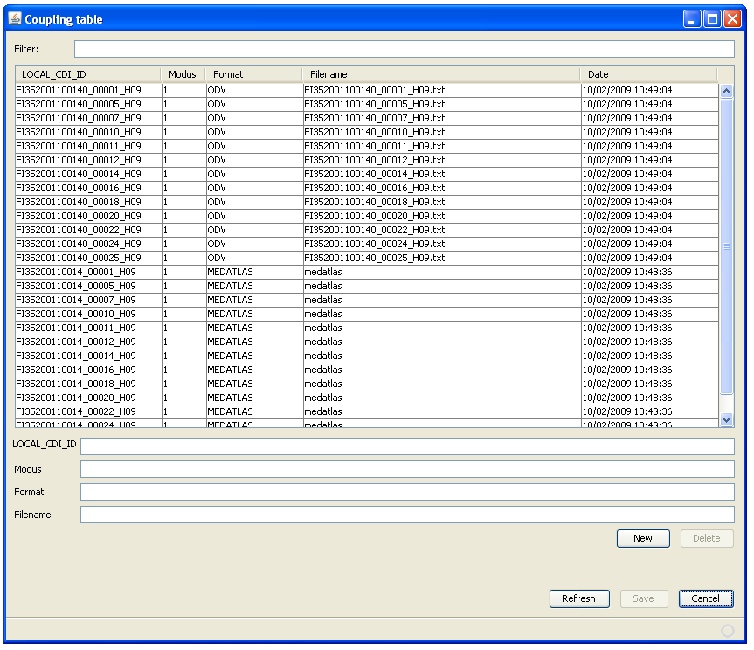
User can:
- Search specific rows in the mapping table using the filter
- Sort the mapping table by clicking the column title
- Delete rows in the mapping table by selecting the row(s) and then click on the “Delete” button. The definitive delete is only done after clicking on Save.
- Insert rows manually in the mapping table by typing the LOCAL_CDI_ID, Modus, Format and Filename in the empty text inputs, then by clicking on New.
- Edit a row by clicking it, then click in one of the editable columns (Modus, Filename, Date) to change it
- Refresh the content of the table from the database. Refresh is cancelling all changes not previously saved.
- Quit without saving by clicking on Cancel.

Export the coupling table
This export function generates a coupling file that will be used by SeaDataNet download manager for retrieving stations in the files. The default name for this coupling file is “coupling.txt”, but NEMO user can change this name in NEMO settings.
The coupling file used by SeaDataNet download manager is unique and called “coupling.txt”. This file must not contain duplicates (the coupling file ID is LOCAl_CDI_ID + format) It’s up to NEMO user to create only one file called “coupling.txt” for SeaDataNet purpose by using the coupling table facilities.
The format of this coupling file is the following:
Local_cdi_ID;Modus;Format;File_name

Import a coupling file
The import function allows to import a coupling file, at the same format as previously described (paragraph 6.7.2), into the coupling table.
This can be useful, if a user prefers to modify the coupling table using a text editor, he can successively:
- Export the coupling table from NEMO,
- Delete the coupling table in NEMO
- Do the modifications he needs with the text editor on the coupling file.
- Import the coupling file in NEMO
- Export the new coupling table for SeaDataNet uses

References
[1] – Lowry R., Fichaut M., Schlitzer R., 2008 - SeaDataNet datafile formats. SeaDataNet report, version 0.2, 12 p.
https://www.ifremer.fr/bscw/bscw.cgi/d93460/Specification%20of%20SeaDataNet%20Data%20Transport%20Formats
[2] Web pages for description of the MEDATLAS format,
http://www.ifremer.fr/sismer/program/formats_phy/formats_UK.htmMEDATLAS format
[3] – Tosello V., Fichaut M., Harscoat V., Larour M. Maudire G, 2009 – SeaDataNet, MIKADO user manual. SeaDataNet report, version 1.1.3, 81 p.
http://www.seadatanet.org/media/seadatanet/files/software/mikado_user_manual

Annexe 1 – Proxy connection to internet
For users having PROXY connection to internet, the nemo.ini file must be modified.
Please add the following 4 lines in C:\NEMO_Installation_directory\nemo.ini and restart NEMO:
-Dhttp.proxyHost=myproxyaddress
-Dhttp.proxyPort=myport
-Dhttp.proxyUser=mylogin
-Dhttp.proxyPassword=mypassword
To get the proxy address and port please do as follow :

Firefox
Go into the following menus :
Edit, Preferences, Advanced, Network, Connection, Settings
If you have got a Proxy configuration, the address and port to add in the nemo.ini file are in the HTTP Proxy and Port fields of the following window:

Internet explorer
Go into the following menus :
Tools, Internet options, Connection, Local Area Network (LAN) settings
If you have got a Proxy configuration, the address and port to add in the nemo.ini file are in the Proxy server Address and Port fields of the following window:

