Département Informatique et Données Marines

FICHAUT M., BOULANGER D.

13/05/2009 – sdn_Mikado_User_Manual_V1.1.02

SeaDataNet

Med2MedSDN V1.1.02 : User manual



SeaDataNet

Med2MedSDN V1.1.02: User manual

SeaDataNet
Title :

Med2MEDSDN: user manual

Reference : sdn_Mikado_User_Manual_V1.1.02  Date : 13/05/2009  Version : 1.1.1  Diffusion : open restricted forbidden | number of pages  16  Language :  English

Name | Date | Signature | Diffusion
Name | Date | Signature |  | Nb ex.
Prepared par :
Fichaut M.

Verified by :
Boulanger D.

Résumé :
Manuel utilisateur du logiciel Med2MedSDN développé dans le cadre du projet Européen SeaDataNet. Ce logiciel est utilisé pour convertir un ou n fichiers au format MEDATLAS en un ou n fichiers au format MEDATLAS avec les extensions SeaDataNet.

Abstract :
User Manual of Med2MedSDN software delivered in the frame of SeaDataNet European project. This software is used to reformat MEDATLAS files to SeaDataNet MEDATLAS files (with extensions specific to SeaDataNet)

Mots-clés :
Format, MEDATLAS, SeaDataNet

Keywords :
Format, MEDATLAS, SeaDataNet

Comments :

History

Version | Date | Status | Comments
1.0 | 18/03/2009 |  | Creation
1.1.01 | 28/04/2009 |  | Update for Med2MedSDN v1.1.01  - manual Proxy configuration  - creation of a coupling file for SeaDataNet download manager
1.1.02 | 13/05/2009 |  | Update for Med2MedSDN v1.1.02  - Restore defaults function in the settings

Content

1. Introduction 7
1.1. Main principles 7
1.2. Technical characteristics 7
1.3. Links with other entities 8
2. Med2MedSDN installation and uninstallation 9
2.1. Med2MedSDN installation 9
2.2. Med2MedSDN uninstallation 10
3. RUNNING Med2MedSDN 11
3.1. Main menu 11
3.1.1. Settings 11
3.1.2. Vocabulary update 12
3.1.3. About Med2MedSDN 12
3.2. Main screen 12
3.2.1. User interface 13
3.2.1.1. Input file or directory 13
3.2.1.2. Output directory 13
3.2.1.3. Generation of a coupling table 13
3.2.1.4. Start conversion button 14
3.2.1.5. Error messages 14
3.2.2. Processing 15
3.2.2.1. File conversion 15
3.2.2.2. Errors management 15

Introduction
For purposes of standardisation and international exchange, SeaDataNet has defined extensions to MEDATLAS format.
These extensions fulfil two functions: they provide a linkage between data and metadata in SeaDataNet system, they provide a linkage to standardised SeaDataNet semantic information such as detailed parameter descriptions.

The extensions consist into additional comment lines such as in the example below:

*SDN_parameter_mapping
*<subject>SDN:LOCAL:PRES</subject><object>SDN:P011::PRESPR01</object><unit>SDN:P061::UPDB</unit>
*<subject>SDN:LOCAL:TEMP</subject><object>SDN:P011::TEMPPR01</object><unit>SDN:P061::UPAA</unit>
*EDMO_CODE=486
*LOCAL_CDI_ID=FI35200220004_00001_H10

There are as many lines of “SDN_parameter_mapping” as the number of parameters in the file. In the previous example 2 parameters are measured : depth and temperature.
There are two additional Key-words : LOCAL_CDI_ID and EDMO_CODE which are used to identify uniquely a data record (one vertical profile, or time series or trajectory) within SeaDataNet system.

Main principles
Med2MedSDN reformats MEDATLAS file(s) without the SeaDataNet extensions to MEDATLAS file()s with SeaDataNet extensions (format called SeaDataNet MEDATLAS).

User can convert one MEDATLAS file or one directory with one to n MEDATLAS files.
Med2MedSDN is bilingual (English – French).

Technical characteristics
Med2MedSDN is a portable software that can be downloaded from the SeaDataNet website http://www.seadatanet.org, free of charge, with its user manual.
It is written in Java Language (Version >= 1.6) and it is available under Microsoft (tested with Windows XP and Vista). Log4j is used for error management.
Med2MedSDN works offline; however as it uses the SeaDataNet common vocabularies web services to update its lists of values, network connection is needed only when update of these lists is necessary.
- To know if Java is available on your computer, in the right version, follow these steps:
    - Open 'Start' menu, then 'Execute'
    - On the displayed window, enter: 'cmd', then click on 'OK' button
    - Enter 'java -version'
- Check if command has been executed:
    - If not, download the last java version at
http://java.com/en/download/index.jsp.
    - Else, check the version displayed. The version should be greater than or equal to 1.6.
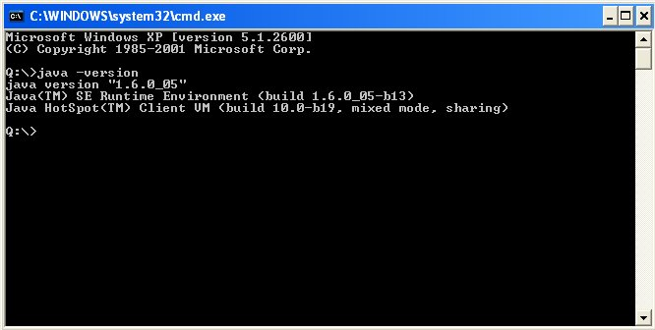
Figure 1 – Check Java version installed on your computer

Links with other entities
Med2MedSDN uses SeaDataNet vocabularies and EDMO for the data file conversion.
The following lists are used by Med2MedSDN:
List Code | List name
Mapping P091-P011 | Mapping between P091 (MEDATLAS Parameter Usage Vocabulary) and P011 (BODC Parameter Usage Vocabulary)
Mapping P091-P061 | Mapping between P091 (MEDATLAS Parameter Usage Vocabulary) and P061 (BODC data storage units)
EDMO | European Directory of Marine Organizations

These lists are available at :
http://seadatanet.maris2.nl/v_bodc_vocab/welcome.aspx

Up-to-date version of the vocabulary list can be downloaded with Med2MedSDN.

Med2MedSDN installation and uninstallation

Med2MedSDN installation
Get Med2MedSDN software from SeaDataNet Web site:
http://www.seadatanet.org/standards_software/software/Med2MedSDN
Copy the zip file on your computer, and unzip it.
You will get 2 files: install_ Med2MedSDN.jar and launcher_ Med2MedSDN.bat
If Java is not installed on your computer (see chapter 1.2) to install it.
To install Med2MedSDN double click on the file launcher_ Med2MedSDN.bat.
Then select your language and run the installation :
- Accept the terms of the license agreement.
- Select the installation path (default is C:\ Program Files\ Med2MedSDN), target directory is created if not exists.
- If you want a shortcut on your Desktop check the box circled in red on the image below. You can create a shortcut for the current user or for all users of the computer (circled in blue), by default “all users” is checked.
Figure 2 – Installation of Med2MedSDN – definition of shortcuts.
The shortcuts are created in the desktop and in the Start menu of the computer with the following icon :
on the desktop or in the start menu under the group define in the circled in green field in Figure 2.
Figure 3 – Last screen of Med2MedSDN installation
If Med2MedSDN needs to be installed on several computers it is possible to “Generate an automatic installation script, by clicking on the appropriate button on the last screen of Med2MedSDN installation (Figure 3).

Med2MedSDN uninstallation
If you want to remove Med2MedSDN from your computer, run the uninstaller by selecting Med2MedSDN Uninstaller in the start menu of your computer (see paragraph 2.1).
If running the uninstaller generate the following message :
please run
C:\Med2MedSDN _Installation_directory\Uninstaller\launcher_uninstaller.bat.
The following window opens :
I
Click on Force the deletion of C:\Med2MedSDN_Installation_directory
And then click on Uninstall.

RUNNING Med2MedSDN

Main menu
The main menu of Med2MedSDN has 3 choices:
- Options/Settings
- Options/Vocabulary update
- ?/About Med2MedSDN

Settings
This screen is to:
- Choose the language of Med2MedSDN. To take into account language change, user must exit and restart the software.
- Modify, if necessary, the address of the Web service used to download SeaDataNet vocabulary.
- Define a manual PROXY configuration: if box “Use manual Proxy configuration” is checked, HTTP Proxy address and Port are mandatory.
- Choose the EDMO_CODE of the marine organisation responsible of data management. If this field is empty data conversion will not work

Figure 4 - Settings screen
A search function is available by right click in the EDMO ID field. It opens the list of EDMO codes ad the filter on this list.

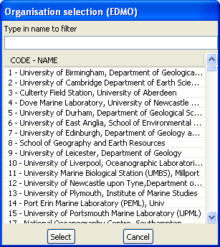
Figure 5 - Selection of the EDMO code in the list

The “Restore defaults” button restores the default values for all the fields of this screen. This action cannot be cancelled.

Vocabulary update
This function is to update the vocabulary lists described in paragraph 1.3; it needs an internet connection and makes use of the Web services defined in the settings of Med2MedSDN.
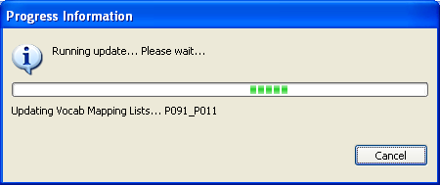
Figure 6 - Progress bar while updating vocabulary list

About Med2MedSDN
The version of the software is available on this screen.
Figure 7 - About Med2MedSDN

Main screen
This screen is to input information necessary to data conversion, and also to run data conversion

User interface
Figure 8 - Main screen of Med2MedSDN

Input file or directory
User must tell Med2MedSDN if he wants to convert one file or one directory (default value is directory).
Then the name of the file or of the directory has to be selected through the “Browse” button.
If a directory is selected, Med2MedSDN converts only the files in this directory, not in the sub-directories if there are some.

Output directory
This output directory where converted files will be written, can be input manually or selected through the “Browse” button.
If this directory does not exist, Med2MedSDN will create it.
The output directory must be different from the input one.

Generation of a coupling table
If box “Generate a coupling file” is checked, while reformatting files, Med2medSDN creates a coupling file (as a text file) which gives the mapping between a unique identifier of a CDI element (LOCAL_CDI_ID which is one station of vertical profiles, one time-series or one trajectory) and the file in which this element can be found. The coupling file is used by SeaDataNet download manager.
The coupling file contains the following information:
- LOCAl_CDI_ID,
- Modus = 1 (for mono-station file), 3 (for multi-station file)
- Format (which is MEDATLAS)
- File name
Example of a coupling file :
LOCAL_CDI_ID;MODUS;FORMAT;FILENAME
FI35200140070_00040_H10;3;MEDATLAS;2001040070.ctd
FI35200140070_00050_H10;3;MEDATLAS;2001040070.ctd
FI35200140070_00060_H10;3;MEDATLAS;2001040070.ctd
FI35200140070_00070_H10;3;MEDATLAS;2001040070.ctd
FI35200140070_00080_H10;3;MEDATLAS;2001040070.ctd
FI35200301012_10239_D01;1;MEDATLAS;200301012110239D
FI35200301012_11943_D01;1;MEDATLAS;200301012111943D
FI35200301012_07160_D01;1;MEDATLAS;200301012207160D

Start conversion button
A click on this button start the validation of input parameters and the control of the EDMO_CODE input (cf paragraph 3.1.1). Once the input parameters are checked and OK, conversion of files starts.

If a coupling file is asked, the first screen (Figure 9) that opens is to enter the name of the coupling file (by default this name is set to coupling .txt), then the user is asked to enter the “Output directory prefix” (Figure 10) which will be subtracted from the file name in the coupling file.
For example if
output file name = C:\username\NEMO\cruise_name\file_name
and output directory prefix = C:\username\NEMO
file name in the coupling file will be : cruise_name\file_name

Figure 9 – Name of the coupling file

Figure 10 – Input of the Output directory prefix

Error messages
Error messages are written in the field under the “Start conversion” button.
Figure 11 - Error message on EDMO Code
This message is reset to empty at each new file conversion.

Processing

File conversion
During the file conversion a separate window opens. A progress bar, the name of the file being converted and its rank /Total number of files are displayed.
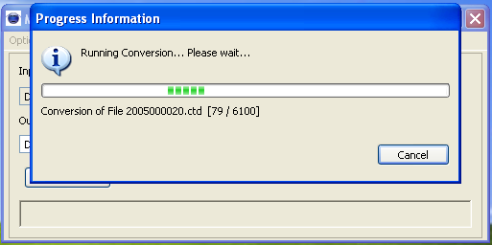
Figure 12 - Progress bar while conversion is running
Conversion can be cancelled at any time by clicking on the “Cancel” button.
For each file being converted, Med2MedSDN :
- Verifies the file format: conversion runs only if the file is at MEDATLAS format (old version) otherwise an error is registered in the “Log file” and the software moves to the next file.
- Writes the additional lines in all the stations of MEDATLAS file just before the line with SURFACE SAMPLE key-word :
    - For each parameter of the input file, Med2MedSDN writes the line for parameter mapping with P011 and P061 SeaDataNet vocabulary lists (cf paragraph 1.3) as for example :
*<subject>SDN:LOCAL:CodeP091</subject><object>SDN:P011::CodeP011</object><unit>SDN:P061::CodeP061</unit>
And the two additional lines with LOCAl_CDI_ID and EDMO_CODE
    - The LOCALCDI_ID is the concatenation of :
      - [Cruise reference] _[station number]_[data type]

Errors management
Errors are registered in a log file which is located in Med2MedSDN installation directory. It can be open through Med2MedSDN main screen by clicking on “see log” in the error window.
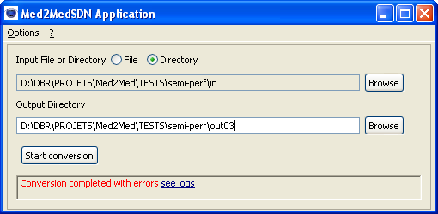
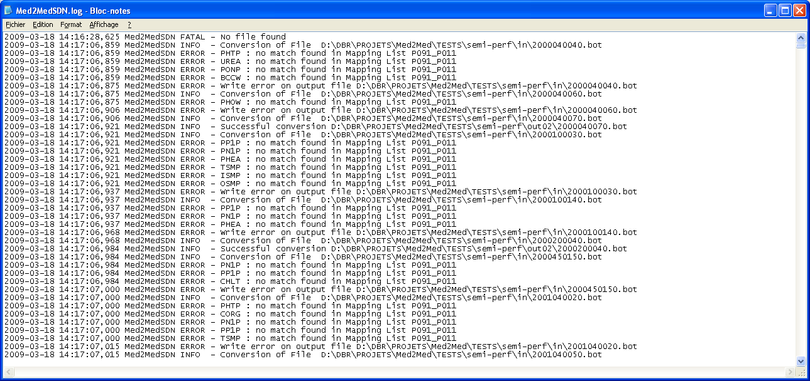
Figure 13 - Log file for errors
Maximum size of the error log file is 5 Mb. When this maximum size is reached, Med2MedSDN saves it and opens a new log file. The software keeps 4 log files maximum and deletes the oldest log files.

One line in the log file is composed as following:
- Date (format ISO 8601)
- Name of the Software
- Error severity level
- Error message

The severity level is one of the three following values:

INFO | Informative messages for starting of the conversion or successful conversion
ERROR | For conversion errors : conversion is cancelled on the current file but continues on the other files
FATAL | For conversion errors which stop the processing of the files

For example :
- If a mapping between P091 and P011 is missing an ERROR is detected and the file containing this parameter is not converted.
- If the EDMO_CODE is missing in the settings of Med2MedSDN a FATAL error is detected and file conversion stops.

